EVALUATING THE PRACTICE OF INDUSTRIAL RELATIONS IN PRIVATE SECTOR

(A CASE STUDY OF BUA CEMENT COMPANY)

ABSTRACT
This project aims at examining the role of Industrial Relations Practices in Nigerian Business Organization. The main objective of the study is to examine the role of industrial relation practice in Nigeria business organization other objectives are to examine the causes of conflict in selected Nigerian organizations, to find out the effects of such conflict on the organization and the society in general, to find out the various forms of industrial relations policy adopted by the management of the organization, and to know how these policies affect labour/management relationship in such organizations. The instrument of the studies includes the use of questionnaires, interview and personal observations. Information so provided was analyzed using simple percentage, for the research question and z-test for the two hypotheses. From the findings, it was found that, lack of adequate condition of service gives rise to conflict, employees; unions are not allowed access to managerial meting and law/policy bothering workers. And government interventions in industrial relations are influenced by conflicts as a result of poor condition of service, management practiced paternalistic industrial relation policy rather than collaborative. The study recommends that employees should be given better conditions of service by management, union leaders should be considered in major decisions.

TABLE OF CONTENTS
TITLE PAGE
ABSTRACT
DECLARATION
CERTIFICATION
DEDICATION
ACKNOWLEDGEMENTS
TABLE OF CONTENT
LIST OF TABLES
LIST OF FIGURES
CHAPTER ONE: INTRODUCTION
1.1 BACKGROUND OF THE STUDY
1.2 STATEMENT OF PROBLEMS
1.3 OBJECTIVES OF THE STUDY
1.4 SIGNIFICANCE OF THE STUDY
1.5 RESEARCH QUESTION
1.6 STATEMENT OF HYPOTHESIS
1.7 SCOPE/LIMITATION OF THE STUDY
1.8 DEFINITION OF TERMS
CHAPTER TWO: LITERATURE REVIEW
INTRODUCTION
2.1 CONCEPTUAL DEFINITION OF INDUSTRIAL RELATIONS
2.2 PARTIES INVOLVED IN INDUSTRIAL RELATION
2.3 RIVIEW OF LITERATURE ON SUBJECT MATTER
2.3.1 INDUSTRIAL RELATIONS IN NIGERIA BUSINESS ORGANIZATION
2.3.2 MANAGERIAL FRAME OF REFERENCE AND COLLECTION BARGAINING
CHAPTER THREE: RESEARCH METHODOLOGY
INTRODUCTION
3.1 RESEARCH DESIGN
3.2 POPULATION OF THE STUDY
3.3 SOURCES OF DATA
3.5 SAMPLE SIZE AND SAMPLING PROCEDURES 30
3.5 METHOD OF DATA COLLECTION 30
3.6 RESEARCH INSTRUMENTS AND METHOD OF DATA COLLECTION 31
CHAPTER FOUR: DATA PRESENTATION AND DATA ANALYSIS
4.1 INTRODUCTION
4.2 HYPOTHESES TESTING
CHAPTER FIVE: SUMMARY, CONCLUSION AND RECOMMENDATION
5.1 SUMMARY
5.2 CONCLUSION
5.3 RECOMMENDATIONS
REFERENCES

CHAPTER ONE
INTRODUCTION
1.1 BACKGROUND OF THE STUDY
Few issues engender more emotions among businessmen and their employees than that of labour management. Some businessmen have folded their operations rather than negotiate terms of employment with their workers union. Even more businessmen have freight long, expenses given “war with labour”. Sometimes successfully, more commonly not. Even most tolerant executives emotional are tasked when discussing labour and its organization. And the picture on the other side is not better. Rare is the union leader who has many king works for employers. More commonly labour at best is suspicion of management motive. Bus-Kupt et al, 1976). In recent times, the voice of the Nigerian workers has become louder, industrial dispute is now a common phenomenon. These disagreements between employees and management had after led to work stoppages, strikes, workouts etc. and such other actions that out rightly reduce the productivity of the average workers.
These actions therefore however, affect the entrepreneurs most since his/her profit on investment will in no doubt be reduced. Managing industrial disputes has been the primary concern of industrial relations practitioners and labour leaders. It has been recognized however, the various kinds of employee grievances often lead to industrial disputes. An industrial dispute is a situation in which two or more groups (management, employees, entrepreneur) perceive that they have in compatibility of goals and Inter dependence of activity. Unless one believes in an utopian world where all interests are additive, overlapping and compatible, one must admit to possible conflicts accompanied by deliberate behaviour, characterized by interference’s and blockages (Flippo, 1984). Employees and organizations need each other and are therefore interdependent.
However, employees and organizations have some values that are conflicting e.g. Ego versus control, self-actualization versus divisions of labour, and freedom versus efficiency (YUSEF, 1981). Sustained your suffering, however breeds a brotherhood of under training, join endeavour and mutual assistance, and it is not surpassing that workers in the circumstances, found it necessary to organize trade unions at the most effective means of both exerting and defending better terms and conditions from their employees. This has been accepted institution with the industrial structure (YUSUF, 1981). As a discipline, industrial relations involved as a study of economic class conflicts between employers on one hand and increasingly organized workers on the other. In essence therefore, the logic of industrial relations seems to have been derived from an interest class conflict.
A total absence of conflicts would be unbelievable, boring and strong indications that such conflicts are being suppressed. One of the characteristics of a mature group is its willingness and ability to bring higher degree of resolving them. Conflict per-se is whether bad nor contrary to good of the organization. However, the first step in conflicts resolution is their discovery and exposure. There are many upwards demands of communication that can be developed for the purpose of bringing dissatisfaction to the surface (Flippo, 1984).
Industrial conflicts have no final or permanent victor as such, for both side employers and workers-mutually supportive. In an important aspect, the problem of industrial relations is derived out of how to organize production and share the returns of their joint endeavour. Symth (1977) defined conflicts as a dynamic process, a type of behaviour involving two or more parties in opposition to each other. Stoner (1977) also have it that organizational conflicts is a disagreement between two or more organizational members or group arising from the fact that they must be scarce resources or work activity and or from the fact that they have different status, values or perceptions. High productivity and stable market economy can only be achieved where there is cordial relationship between employers and employee for this reason as (Rothwel, 1984) puts it. Government regards itself as mandated to produce trade unions powers, and has adopted a strategic approach.
Laws and decrees have been promulgated at several instances to restrict the scope of industrial actions at risk and reducing the scope of closed shops and union membership agreements, but this has only succeeded in reforming rather than eliminating them.
Although, studied have been advanced on conflict management, very little has been done having in mind the contemporary Nigerian organizations and little emphasis has been given to the process of generating and exposing distraction faction in organization. Not with standing, managerial industrial relations policies could also help.

1.2 STATEMENT OF PROBLEMS
In most Nigeria organization, it has been the responsibility of the management to maintain a stable labour force and to stimulate the efforts of its members in a positive manner by providing those essential materials that are needed for effective work performance, if in one way on the other management fail to comply with the stipulation of the workers handbook which could eventually lead or result to industrial conflict if not settled will be detrimental to the organizational objectives. Industrial conflict tends to slow down productivity in some cases stop productivity in organization objectives and goals.

1.3 OBJECTIVES OF THE STUDY
The focus of this study has it’s as follows:
1. To examine the causes of conflict in the selected Nigerian organizations.
2. To find out the effects of such conflict on the organization and the society in general.
3. To find out the various forms of industrial relations policy adopted by the management of the organization.
4. To know how these policies affect labour/management relationship in such organization.
5. To examine how conflict are managed so as to bring about higher productivity in the interest of labour and management.
1.4 SIGNIFICANCE OF THE STUDY
The value of any study lies in its usefulness to the society. In view of this fact therefore, this study which focuses on the role of industrial relations practices in the Nigerian organizations is of most useful to labour leaders and management of the oil industries and government owned parastatals.
Apart from its value to decision makers in organizations, this study is of immeasurable importance to students and lecturers of the faculty of management sciences who may like to further their understanding of the role of industrial relations practices in both government owned parastatals and outside firms.
Above all, it is therefore hoped that this study will stimulate further studies in this area.

1.5 RESEARCH QUESTION
In order to achieve the objectives of the study the researcher decided to postulate some question that will guide the researcher. They are:
1. What are the common sources of conflict in the organization?
2. What effects do these conflicts have on the organization workers, management and the society?
3. What kind of industrial relations policy does the management of the organization actually practice.
4. What are the inbuilt devices that are aimed at resolving conflicts?
5. How do workers (unions) perceive management’s action?
6. What role does management plays in trying to encourage industrial peace and harmony?

1.6 STATEMENT OF HYPOTHESIS
In order to achieve the objectives of the study and answer the research questions well framed hypotheses were formulated as follows:
H0: There is no significant relationship between industrial relations practices in an organization and its success of survival.
H1: There is a significant relationship between industrial relations practices in an organization and its success of survival.
HO: There is no significant relationship between industrial relations practices, and organization effectiveness.
H2: There is a significant relationship between industrial relations practices, and organization effectiveness.

1.7 SCOPE/LIMITATION OF THE STUDY
The study is designed to focus on BUA Cement Company in Sokoto State. This study will be limited to the study of industrial relations practices in the company. The short period required for all completion of the study would introduced elements in rush, which will affect the researcher’s performance. Besides lack of enough money is also another chronic limitations among students of which the researcher was not exempted.
The sample size involving five (5) company branches and statistical error will also constitute the major weak point to the study, notwithstanding, the researcher believes that, the data generated will guarantee reasonable conclusion therein.

1.8 DEFINITION OF TERMS
The words below are peculiar to the study and needs to be defined technically to avoid. They are:
INDUSTRIAL RELATION: Refers to the regulation of contact of employment situation based on democratic principles by the employer/management and workers union or government acting as an umpire.
UNIONS: Refers to as a collectivity of workers formed for the purpose of increasing their bargaining strength in order to achieve improved terms and conditions of employment.
STRIKE: Any situation or condition of all workers in an employees and management resulting in stoppage of work.
INDUSTRIAL UNION: Is the uniting of all workers in an organization irrespective of their craft, trade, occupation or grade of skill to achieve a common goal.
PRACTICE: Refers to routine test cement out by industrial relations experts for the purpose of a achieving peace and harmony in organization.

CHAPTER TWO
LITERATURE REVIEW
2.0 INTRODUCTION
2.1 CONCEPTUAL DEFINITION OF INDUSTRIAL RELATIONS
Industrial relations exist wherever employers and employees work together. The field of industrial relations (also called labour relations) looks at the relationship between management and workers, particularly groups of workers represented by a union (Wikipedia 2008). It is the collective aspect of relations between management and its workforce. According to Pettinger (1999), industrial relations is the system by which workplace activities are regulated, the arrangement by which the owners, managers and staff of organizations come together to engage in productive activity. Further, Pettinger (1999) said industrial relations concerns setting standards and promoting consensus, and managing conflict.
Armstrong (2003) also submits that the starting point of an employment relationship is an undertaking by an employee to provide skill and effort to the employer in return for which the employer provides the employee with a salary or wage. The relationship is initially founded on a legal contract. This may be a written contract but the absence of such a contract does not mean that no contractual relations exist. The employer’s obligations include the duty to pay salaries or wages, to provide safe work place, to act in good faith towards the employee and not to undermine the trust and confidence of the employment relationship. The employee has corresponding obligations, which include obedience, competence, honesty and loyalty.
Hyman (1975), also states that the focus of industrial relations is on how conflict is contained rather than how disagreements or disputes are generated. Hyman is of the view that industrial relations is the study of processes of control over work relations. Flanders’ (1970) opinion is that a labour relation is the study of the institutions of job regulations. By this definition Flanders (1970) believes that there are formal and informal rules governing employment. Industrial relations therefore, deals with the ways these rules are created, interpreted, administered and changed with the organisation involved in the rule making process. The term “labour relations” connotes conflict resolution processes, because of the differences in goals, conflicts between unions and employers are real and to some extent always underlie the relationship between unions and employers. That is not to say that unions and employers do not have similar goals. The parties have some goals in common, and in the labour relations process, they both try to accommodate each of the parties’ separate goals while enhancing the likelihood of realizing common goals.
According to DeSimone and Harris (1998), labour relations activities include developing communication systems through which employees can address their grievances and problems. Obeng-Fosu (1999) also submits that the parties involved in industrial relations are the trade unions, employers as well as the government. An important factor to remember about the employment relationship is that generally, it is the employer who has power to dictate the contractual terms unless they have been fixed by collective bargaining. Individuals, except when they are in much demand have little scope to vary the terms of the contract imposed on them by their employers. Pettinger (1999), also is of the view that the framework of industrial relations is tripartite.
Obeng-Fosu (1999) and Pettinger (1999), agree that industrial relations involve the work of three groups of people which is the legal framework or components of industrial relations.
2.2 PARTIES INVOLVED IN INDUSTRIAL RELATION
Components of industrial relations
Pettinger (1999), posts that the components of industrial relations is tripartite and the parties involved are the government; employees, their representatives and trade unions; and employers, their representatives and associations. Pettinger (1999) further, states that the first party, the government is the single major universal influence on industrial relations everywhere. It is the single largest employer responsible for the pay, terms and conditions of employment of the civil service, the armed forces, the police, the emergency services, local government and services, nationalized industries and utilities, health and social services. The government sets standards of employment and industrial relation practice that others would be expected to follow. It makes employment and industrial relations laws, and set the standards and boundaries for practice. The government also establishes codes of conduct, codes of practice and employment protection policies.
Pettinger (1999) also records that the second party in the tripartite is the employees. He says the interests of employees at the workplaces are looked after by trade unions, staff associations, some professional bodies and the individuals themselves, but over the years the greatest single influence has been trade unions. Trade unions were first established to protect employees’ interests. The employer is represented by trade federations and associations, individual companies and organizations. The function of the employer in industrial relations is to set standards of staff management, attitudes, behaviour and performance for the organization or company, to set terms and conditions of employment, and pay levels and methods and to act in a fair and reasonable way towards all employees at the workplace. The diagram below shows the players in industrial relations and how they are related. The distribution of power amongst these groups can greatly shape the way an economy functions (Wikipedia 2008).
2.3 RIVIEW OF LITERATURE ON SUBJECT MATTER
Theoretical perspectives of industrial relations
Industrial relations scholars have described three major theoretical perspectives or frameworks that contrast in their understanding and analysis of workplace relations (http://en.wikipedia.org/wiki/Industrial_relations). This site, states three theories or views of industrial relations known as unitary, pluralist and radical. Each of these offers a particular perception of industrial relations and the study takes a look at these individually.
The unitary perspective
In unitary, the organization is perceived as an integrated and harmonious whole with the ideal of “one happy family” where management and other members of staff all share a common purpose, emphasizing mutual cooperation. Furthermore, unitarism has a paternalistic approach where it demands loyalty of employees, being predominantly managerial in its emphasis and application. Consequently, trade unions are deemed as unnecessary since the loyalty between employees and organizations are considered mutually exclusive, where there cannot be two sides of industry. Conflict is perceived as disruptive and the visible result of agitators, interpersonal friction and communication breakdown.
The pluralist perspective
In pluralism, the organization is perceived as being made up of powerful and divergent sub-groups, each with its own legitimate loyalties and with their own set of objectives and leaders. In particular, the two predominant sub-groups in the pluralist perspective are the management and trade unions. Consequently, the role of management would lean less towards enforcing and controlling and more toward persuasion and co-ordination. Trade unions are deemed as legitimate representatives of employees; conflict is dealt by collective bargaining and is viewed not necessarily as a bad thing and, if managed, could be channeled toward evolution and positive change.
The radical perspective
This view of industrial relations looks at the nature of the capitalist society, where there is a fundamental division of interest between capital and labour, and sees workplace relations against this history. This perspective sees inequalities of power and economic wealth as having their roots in the nature of the capitalist economic system. Conflict is therefore seen as inevitable and trade unions are a natural response of workers to their exploitation by capital. Whilst there may be periods of agreement, the Maxist view would be that institutions of joint regulation would enhance rather than limit management’s position as they presume the continuation of capitalism rather than challenge it.

2.3.1 INDUSTRIAL RELATIONS IN NIGERIA BUSINESS ORGANIZATION
Factors Impacting Industrial Relations
Industrial relations are impacted with so many other factors besides the day to day working relationship between workers and management inside the workplace and these factors are beyond the immediate purview of them. Below are the main factors impacting IR:
1. Economic Factors: Economic factors include, economic organizations – capitalist vies, communist approach and a mixed of both etc. the structure of labour force, demand for and supply of labour force. Availability and demand for skilled v/s unskilled workforce.
2. Technological Factors: the amount of automation, mechanization, manpower rationalization and computerization are some of the reasons making rampant changes in the industry.
3. Institutional Changes: these institutions include government policies, labour legislation, collective agreements, different employees and employers’ federations and like local community etc.
Labour is embodied in human beings and it’s not a commodity. This is the emphasis on the theoretical and policy foundation for the field of Industrial relations. Institutional-based definition of industrial relations is defined as these are the sum of institutions and institutional processes that establish and administer the rules regulating workplace relations. Social Psychology-based definition of industrial relations: These are the sum of social psychological interactions between individuals.
Class-based definition of industrial relations (Suzanne, 2000): These are the sum of institutions, interactions and processes that are a product of wider social and economic influences, in particular the class divisions of contemporary capitalism.
Important Definitions of Industrial Relations
Accordingly to the ILO “industrial relations deal with either relationships between the state and the employers and the workers’ organizations or the relations between the occupational organizations themselves”. The ILO uses the expression to denote such matters as freedom of association and the protection of the right to organize, the application of the principles of the right to organize the right to the collective bargaining, collective agreements, conciliations and arbitration and machinery for corporation between the authorities and the occupational organization at the various levels of the economy”.
According to R. A. Lester, industrial relations “involve attempts to have workable solutions between conflicting objectives and values, between incentive and economic security, between discipline and industrial democracy, between authority and freedom and between bargaining and cooperation”.
Industrial relations encompasses the processes of regulation and control over workplace relations, the organization of tasks, and the relations between employers and their representatives, and employees and their representatives, and is the sum of economic, social and political interactions in workplaces where employees provide manual and mental labor in exchange for rewards allotted by employers, as well as the institutions established for the purpose of governing workplace relations (Bruce Kaufman, 2001).
History and Genesis of Industrial Relations
Industrial Relations are the most primitive form of Personnel Management, which goes back to the eighteenth century. It has relevance right from the 1769, when James Watt fought for the patent of the steam engine. Industrial Relations borrows its basic principles from various disciplines e.g. Economics such as wages, bonus, monetary benefits; Law as labor laws; sociology which includes trade unions and their social framework.
In the last two centuries, there have been three inter related revolutions which marked the evolution of industrial relations into its present form. The three revolutions are:
- Industrial Revolution
- Democratic Revolution
- Capitalist Revolution
Pre industrial revolution era –
This period refers to the prior to industrial revolution in the world. This was the time while there was no formal way of establish relationship between employers and employees. This era is marked basically with the following features:
- In this time period, economic activity was restricted to agriculture, craftsmanship, trademanship and domestic service.
- The workforce was largely illiterate and not professionally qualified.
- There were no defined work hours rather working hours were long. Consideration of human fatigue and its impact on efficiency was missing.
- There was no structured relationship rather it was based on master and the craftsman basis. There was more focus on personal rather than professional.
- The work place, work environment and conditions were improper did not receive any attention.
Industrial revolution
Industrial revolution brought about a transformation in the economic and social life. It began in the UK and then soon spread to France, Germany, and the USA. This period was extensively marked by the studies made by Taylor and his principles of scientific management. The salient features of the industrial revolution are:
It was driven by a series of connected events, which brought about innovation and technology in the factory premises, replacing manual labor and redefining the Man-Machine relationship.
- The concept of factory came to existence and a lot of experiments were conducted to increase productivity. The focus was mainly on efficiency.
- Brought about the concept of free labor market i.e. commoditizing labor. Before, the supply side was governed by some groups and unions and the markets were generally held by master craftsmen.
- Formalization of contract based relationship.
- Different countries experienced industrial revolution at different times. It started at UK, and then spread to USA, France, Germany, Japan, and China. These countries had a regulated market protected by the government. Industrial revolution greatly impacted some countries and towards its end, 80% of the production was dominated by 20% of the countries, which contributed to 20% of the world’s population.
Democratic revolution
Democratic revolution refers to giving consideration for involvement of people in things which matter to them. Democratic revolution is the next important event in industrial relations which impacted industrial revolution. It started in 1750 in UK and then spread to USA and then France. This revolution brought about a change in the political governance of the countries and focused on labour. These Countries moved from colonialism to different arrangements. The salient features of the democratic revolution are:
There was an increase in social concerns for human rights. During the industrial Revolution as human rights were suppressed and workers were not allowed to voice their opinions. The Democratic revolution changed the way workers were treated.
It impacted trade unionism positively. The countries where unionization was banned and considered a sin, changed and took to the new norms e.g. In Germany, Trade Union was not accepted before the democratic revolution and the same goes for USA, where trade unions were banned in certain sectors.
Capitalist Revolution
Capitalist revolution is the next phase in the course of industrial relations. This revolution changed industrial relations significantly. There were certain changes in the society after the capitalist revolution. Some of the features of capitalist revolution are given as below:
- It initiated the provision for private ownership of means of production in industries and their use for personal benefits
- Building freedom of contract for employment conditions
- Employment relation is natural outgrowth of Capitalist
- Capitalist revolution in industrial relation unequal authorities between the parties
This Capitalism caused a divide in society between rich and poor and between employer and the employee. Infact, the capitalism added a negative flavor to the social structure and thus arose certain conflicts. The effects of Capitalism can be categorized as follows. Capitalism has both positive and negative impacts, some of the key features are given below:
- Capitalism has increased the basic indicators of well-being such as life expectancy, real per-capita income, working hours, and working Conditions
- Growth and emergence of working class consciousness
- Worker led protests and strikes
- Worker created trade unions which tried to become economic oriented bodies
- Public attention to labor problems and social question.
Period 1930-1955 of Industrial Relations
During this phase of industrial relations the industries had already faced depression. This period caused a shift from crafts union towards industries unions. Infact, crafts union were opposed to the idea of organizing workers on industries basis. This period marked the new generation of academicians. It marked new reforms and introduction of government regulations which redefined industrial relations as till this time government was not playing an active role. 1932 witnessed highest unemployment and this period continued till 1944 which reflected in, extreme trends of unemployment.
Some of the features of this era were that the economists studied new market fractions and operation of labor markets. The academicians focused on the concept of wage recognition for employees. The government role came in picture in the form of government regulations by way of involvement and participation in labour market. All these above aspects helped shaping up the industrial relations.
The new features emerged from this were:
- Inter wage structure was adopted for labour force
- Wage differentiation among the different workers of different sectors. This was a boon for workers to get the wages according to their nature of work.
- The field of benefits was introduced such as bonus, leaves, medical facility in some cases.
- Internal pattern and rules for the movement of workers formulated.
- During this phase, formulation of various systems came in place in the form of job discipline and capturing attendance and employee performance etc.
- Procedure for dispute resolution adopted the way of formulating and adopting various labour legislations
- Legal status of government regulations
- Collective bargaining system between employer and employee evolved.
- Thus today’s industrial relations have evolved from what emerged during this period.
- Period 1950-1970 of Industrial Relations
- After the Second World War, there has been significant reforms happened across the globe. The country has taken initiatives in these reforms.
- New ways of dealing with human resources given a concern.
- New Generation of labor economists seems to have evolved where quantification of economics was done which wasn’t seen before; the use of numbers became important, so did the use of tools such as HR Matrix, HR Scorecard, econometrics etc.
- Expansion of Business Schools (Harvard B Schools, Other Schools in US) and a new pool of management thoughts emerged.
- Industrial Relations are seen as a Systems Approach.
Need & Importance of Industrial Relations
Productive industrial relations are always the key for the progress and success of any organization as well as for its employees (Schuler, 1989). The need and importance of IR has been discussed with specific points as below:
- Smooth Running Of Operations:
One of main benefit is ensuring smooth running of operations in the plant. It ensures continuous production which serves continuous employment to all the employees in the company. Continuous running of operations ensure optimum utilization of resources and improvement in efficiencies and productivity which directly impacts the companies bottom lines positively.
- Improvement in Product Quality
In view of good industrial relations employees and workers are more motivated and take increased ownership for their jobs on the floor. They take full ownership of the jobs which reflects in timely delivery of quality products. This not only reflects better quality product and services to customer but also help in reducing waste and saving the cost in the process.
- Reduction in Industrial Disputes
Good industrial relations reduce the industrial disputes. Because disputes are reflections of the failure of basic human urges or motivations to secure adequate satisfaction or expression which are fully cured by good industrial relations. Strikes, lockouts, go-slow tactics, and grievances are some of the reflections of industrial unrest which do not spring up in an atmosphere of industrial peace. It helps promoting co-operation and increasing production.
- Increase In Employee Morale
The harmonious industrial relations impact employees morale directly across levels be it workers or officer of the company. In this scenario, there is increased teaming among employees and they work with great enthusiasm with the feeling in mind that the interest of employer and employees is one and the same. Every worker gets the feeling of being a co-owner of the gains of industry. All employees take full ownership of their respective targets and there is complete unity of thought and action is the main achievement of industrial peace. This increases the place of workers in the society and their need of recognitions gets satisfied.
- Employee Engagement and Mental Revolution
Good industrial relations impact employees’ engagement positively. Consequently, the industrial peace lies ultimately in a transformed outlook on the part of workers and employees. Hence its imperative on the part of company leadership, employees and Government to work out a new relationship in consonance with a spirit of true democracy. They should think themselves as partners of the industry and the role of workers in such a partnership should be recognized. This above partnership and relationship becomes mutual rewarding for all of them and further contributes to good industrial relations.
Industrial relations are maintained on the basis of cooperation and recognition of each other. This help to increase production. Wastage of man, material and machines are reduced to the minimum and thus national interest can be protected. Thus, it is seen that good industrial relations are basis of higher production with minimum cost and higher profits. It also results in increased efficiency of workers. New changes can be initiated in the company easily. It also facilitates introducing new things for the welfare of the workers and to promote the morale of the people at work. An economy organized for planned production and distribution, aiming at the realization of social justice and welfare of the massage can function effectively only in an atmosphere of industrial peace.
2.3.2 MANAGERIAL FRAME OF REFERENCE AND COLLECTION BARGAINING
Good Industrial Relations implies peaceful, harmonious, fruitful relations between labour and management. The following steps may help achieve good industrial relations:
- Strong and Stable Union
Management need to recognize the fact that a sound and strong union is essential for ensuring good industrial relations. A strong union would have it easy to carry forward company plans and get then implemented from all the workers. The employees ignore weak union as they think that it hardly represents the workers and can not defend their case in front of the management. Strong and stable union represents workers and can effectively negotiate (Tickner, 2002) with management about the terms and conditions of the service for workers.
- Mutual trust
Trust is the backbone for any relationship. Management and union should help in development of atmosphere of cooperation, confidence and respect for each other. The management must adopt a progressive outlook and should recognize the rights of workers. Also labor unions should persuade their members to work for the common objectives of the organization. Both the management and the unions must have faith in collective bargaining and other peaceful methods of settling disputes among themselves. Mutual trust also leads to mutual respect between the parties.
- Employees’ Participation in Management
The relationship between workers and employer will more impactful when they listen to each other and resolve issues mutually. The management must ensure that the participation of workers in the management of the industrial unit should be encouraged by making effective use of works committees, joint consultation and other methods. This improves communication between managers and workers, increase productivity and lead to greater effectiveness as team.
- Effective Employees Communication

Communication plays an important role in any organization to run it smoothly. A proactive, effective and objective communication helps remain employees focus on their jobs than falling prey to grapevines. Hence communication not only plays a significant role, getting employees know about company plans etc but it also helps curbing any rumors and confusions among employees. The company must build effective structured communication plans, and role it out regularly to keep employees informed about the various developments. Hence regular communication is plays an important role and contributes directly to maintain good Industrial Relations.
Mutual Appreciation and Accommodation
Industrial will be sound only when the bargaining power of the employees’ union is equal to that of management. The employers must recognize the right of collective bargaining of the trade unions. There must be a great emphasis on mutual accommodation rather than conflict or uncompromising attitude. There is a need to appreciate and understand that conflicting attitude does not lead to amicable labor relations; it may foster union militancy as the union reacts by engaging in pressure tactics. The approach must be of mutual give and take rather than take or leave. The management should be willing to co-operate and always look for WIN – WIN resolutions.
- Implementation of Agreements

Unions are helpful for the promotion and maintenance of uniform policies in the company and they play a role in implementing many policies pertaining to shop floor and other wise. The management should also sincerely implement the settlements reached with the trade unions. The agreements between the management and the unions should be enforced both in letter and spirit by both the parties. In case, the agreements are not implemented, then both parties - union and management stop trusting each other. An environment of uncertainty is created. To avoid this, efforts should be made at both ends to ensure the follow up of the agreements.
- Sound Personnel Policies
The points should be noted regarding the personnel policies. Policies should be formulated in consultation with the workers and their representatives if they are to be implemented effectively. It needs to be clearly stated so that there is no confusion in the mind of people. Implementation of the policies should be uniform throughout the organization to ensure fair treatment to each worker.
- Role of Management
There should be progressive outlook of the management of each industrial enterprise (Kochan, 1984). It should be conscious of its obligations and responsibilities to the owners of the business (Jensen, 1983), the employees, the consumers and the nation. The management must recognize the rights of workers to organize unions to protect their economic and social interests.
- Role of Government

The Government should play an effective role for promoting industrial peace. It should be provided with requite authority for settling the industrial disputes. It should help make law for the compulsory recognition of a representative union in each industrial unit. It should intervene to settle disputes if the management and the workers are unable to settle their disputes. This will restore industrial harmony in the companies.

CHAPTER THREE
RESEARCH METHODOLOGY
3.0 Introduction
This chapter presents the design of the study, area of study, population, sample and sampling techniques, instrument used for data collection, validity and reliability of the instrument, procedure for data collection and method of data analysis.
3.1 Research Design
The research design adopted for this study is the descriptive survey design. Descriptive design studies are mainly concerned with describing events as they are without any manipulation (Ali, 1996). This method does not aim at manipulating or controlling any variables under investigation, rather the main predisposition is to observe occurrences at a point (Cross-sectional). The method has the advantage of accommodating many variables as the researcher desires in addition to its cost effectiveness.
3.2 Area of the study
The research study covers five selected BUA cement company branches. The population is made up of civil servants, workers and managers.
3.3 Population of the study
The total number of Registered SMEs in Nigeria (who are also MAN members and registered under CAC as an enterprise) is 44,182 (SMEDAN/NBS, 2012). We narrowed ours down to BUA Cement Company in Sokoto state in addition to this, they have records that would allow a study to be carried on them. The population of the study was 120 personnel and employers.
3.4 Sample and Sample Technique
The sample for the study is 120 personnel and employers. The researcher used multi stage random sampling technique in selecting the samples.
3.5 Instrument used for data collection
The instrument used for data collection was a structured questionnaire. They were drawn strictly based on an extensive literature search on the topic. The questions and the demographic settings will be divided into sectors.
3.6 Validity of the Instrument
The instrument was face and content validated by three experts from Human resources. The questionnaire was given to them along with the research questions and hypotheses to enable them check whether the items in the questionnaire were relevant and adequate enough to answer the research questions and test the hypotheses posed for the respondents.
On the basis of their comments, amendments were made on the questionnaire in terms of relevance, question reconstruction and language use (grammatical corrections).
It was selected due to test Cronbach Alpha equation, table (1) shows the following:
1. Alpha value of performance efficiency dimension reached to (0.70).
2. Alpha value of employees’ satisfaction dimension reached to (0.82).
3. Alpha value of advantages of delegation at organization dimension reached to (0.77).
4. Total was (0.82).
All these values are more than (0.60). So, tool is valid
3.7 Reliability of the Instrument
The instrument was further subjected to trial testing using participants and instructors who are linked to the service or retired. In this study, a pilot survey was carried out to ensure the reliability of the instrument used for the study. This was achieved through the distribution of 30 questionnaires to respondents from another area distinct from our area of study. Here, a measure of reliability called Cronbach’s alpha was employed.
The formula is as follows:
= K (Cov/Var)
- (k-1)(Cov/Var)
Where
K = number of items on the survey.
Cov = Average inter item covariance.
Var = Average item variance.
I = Constant.
A Cronbach’s alpha value ( ∞ ) of greater 0.760 indicated very strong reliability.
3.8 Procedure for Data Collection
The researcher administered 120 copies of the questionnaire to the respondents at their various adult education centres. At the end of the administration, 120 copies of the instrument were returned. Four research assistants helped the researcher in distributing and collecting the questionnaire. The assistants were trained on the objective and importance of the study to enable them give it effective attention.
3.9 Method of data analysis
The researcher made use of the weighted mean in analyzing the data collected from the research questions. The cut-off point for accepting an item is 2.50. Any item from 2.50 and above represents agreed, while mean score of an item below 2.50 indicates disagreement with the items. To analyze the hypotheses, t-test was used to determine the statistical difference between the mean ratings of participants and instructors at .05 level of significance.
3.10 Sources of Data
The researcher employed the use of both the primary and secondary sources of data. Copies of questionnaires were distributed to respondents so as to elicit responses. However, only Company operators would be personally interviewed by the researcher.

To determine the sample size for the study, the sample size formula for finite population according to Cochran (1963) is used;
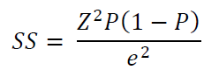

Where; SS= Sample Size.
Z = Given Z value (1.96 for a 95 percent confidence level).
p = Percentage of population (i.e. estimated proportion of an attribute).
e = Confidence level (desired level of precision).
P = Population Size.
Therefore,
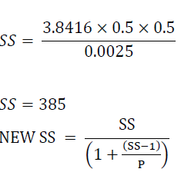
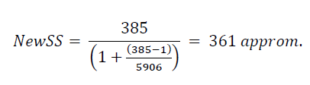
New Sample Size = 361
The questionnaire was used for data collection. This was designed according to the objective of the study.

CHAPTER FOUR
DATA PRESENTATION AND DATA ANALYSIS
4.1 INTRODUCTION
4.2 HYPOTHESES TESTING
Correlation analysis and T-test statistics were used to analyze the hypotheses. The correlation analysis measures the nature of the relationship between two or more variables with a system of equations. T - The test measures the difference between two population means when the sample size is large.
Objective One: To examine the nature of relationship between integrative bargaining and industrial relations climate variables in BUA Cement Company.
Research Question One: What is the nature of relationship between integrative bargaining and industrial relations climate variables in BUA Cement Company?
Hypothesis One: There is no significant difference between integrative bargaining and industrial relations climate variables in BUA Cement Company.
Table-1. The nature of relationship between integrative bargaining and industrial relations climate variables: Correlation analysis.
Paired samples correlations
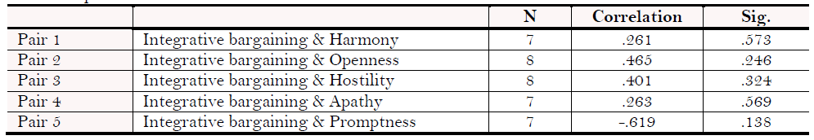
The findings from the correlation analysis Table 1 shows a significant positive relationship between integrative bargaining and four dimensions of industrial relations climate (harmony, openness, hostility and apathy) in BUA Cement Company while there is a negative relationship between integrative bargaining and promptness. This implies that harmony, openness, hostility and apathy have positive influence on integrative bargaining whereas promptness has a negative influence on integrative bargaining.
The findings from the t-test analysis above shows no significant difference between integrative bargaining and industrial relations climate dimensions (harmony, hostility, apathy and promptness) in BUA Cement Company, while there is a significant difference between integrative bargaining and openness as a dimension of industrial relations climate in BUA Cement Company since the p-value is less than 0.05 at a 2- tailed test.
This support the research findings of Pyman et al. (2010) that employee’s perceptions of the industrial relations climate are more likely to be favourable if they have access to direct voice arrangements. Where management is perceived by employees to oppose unions (in unionised workplace), the industrial relations climate is more likely to be reported as poor. The findings of this study also gives credence to the notion according to Wu and Lee (2010) which confirmed that the harmony and openness aspects of industrial relations climate had a positive and significant correlation with the effectiveness of participatory management, including the personnel, operational and social matters. Also, Deery and Iverson (2005) findings revealed that perceptions of a cooperative labour relations climate were positively influenced by procedural justice, the union’s willingness to adopt an integrative approach to bargaining and management’s willingness to share information freely with the union.
Table-2. Significant difference between integrative bargaining and industrial relations climate: T-test analysis.
Paired samples test
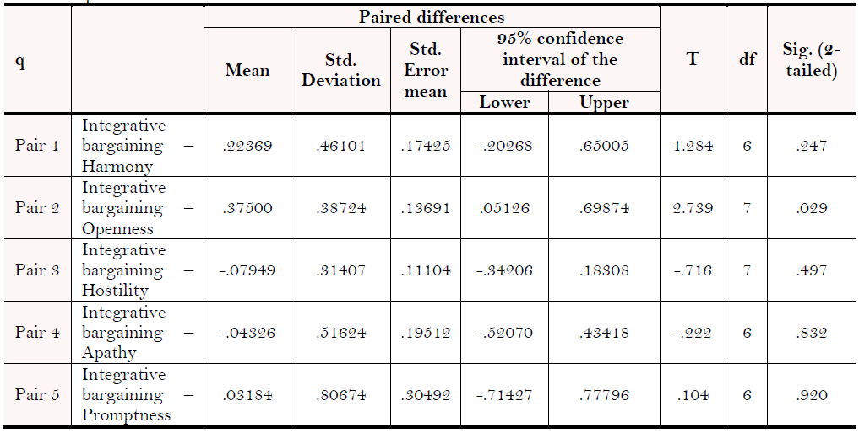
Objective Two: To examine the nature of relationship between unions leadership behaviour and industrial relations climate variables in BUA Cement Company.
Research Question Two: To what extent does unions’ leadership behaviour influence industrial relations climate variables in BUA Cement Company?
Hypothesis Two: There is no significant difference between unions’ leadership behaviour and industrial relations climate variables in BUA Cement Company.
Table-3. The nature of relationship between leadership behaviour and industrial relations climate: Correlation analysis.
Paired samples correlations
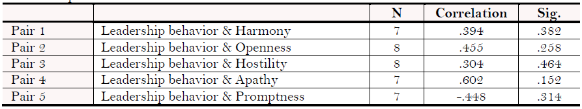
Table 3 of the correlation analysis above show that leadership behaviour has a significant positive relationship between industrial relations climate dimensions (harmony, openness, hostility and apathy) while there is a negative relationship between leadership behaviour and promptness. This means that harmony, openness, hostility and apathy have positive influence on leadership behaviour whereas promptness has a negative influence on leadership behaviour.
Table-4. Significant difference between leadership behaviour and industrial paired samples test.
Relations climate: T-Test analysis
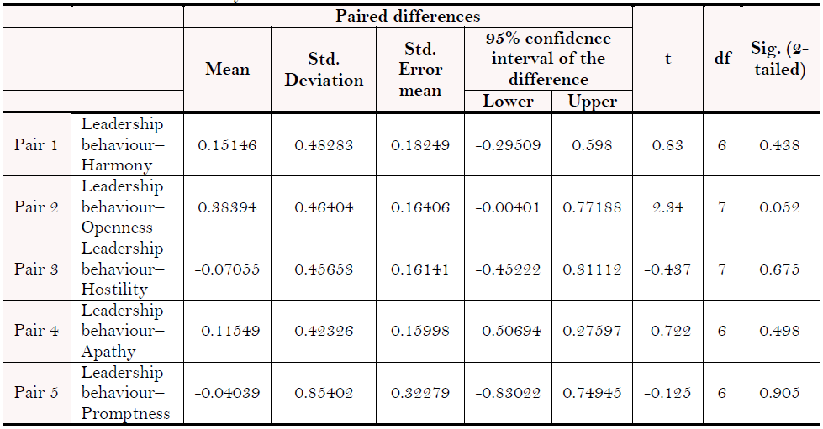
The findings from the t-test analysis above shows that there is no significant difference between leadership behaviour and industrial relations climate dimensions (harmony, openness, hostility, apathy and promptness) in BUA Cement Company, since the p-values are greater than 0.05 at a 2- tailed test.
This confirmed the finding of Redman and Snape (2005) that a marked deterioration in the industrial relations climate result to changes in union leadership and to an increase in union commitment and participation amongst ordinary members. The poor climate created the conditions for union renewal by bringing forward union activists with more inclusive styles and by raising membership awareness of the need to vigorously defend their existing terms and conditions.
Objective Three: To examine the nature of relationship between unions density and industrial relations climate variables in BUA Cement Company.
Research Question Three: What is the nature of relationship between union density and industrial relations climate variables in BUA Cement Company?
Hypothesis Three: There is no significant difference between union density and industrial climate variables in BUA Cement Company.
Table-5. The nature of relationship between union density and industrial relations climate: Correlation analysis.
Paired samples correlations
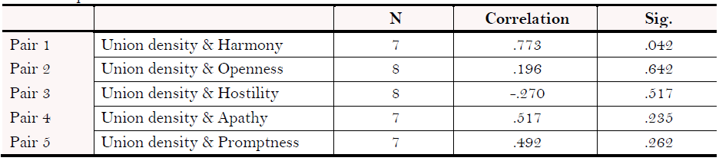
The Table 5 correlations are positively related except for union density and hostility. This shows that harmony, openness, apathy and promptness have positive influence on union density while hostility has a negative influence on union density.
Table-6. Significant difference between union density and industrial relations climate: T-test analysis
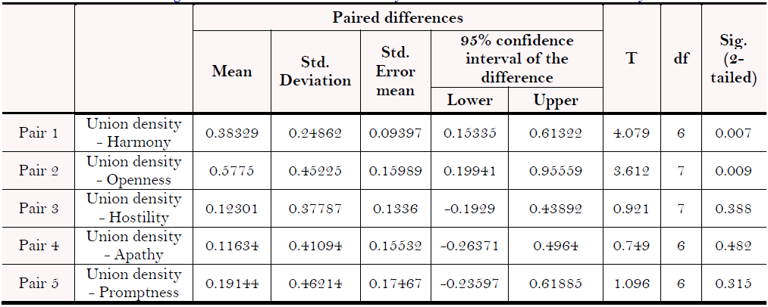
The findings from the t-test analysis above shows that there is no significant difference between union density and industrial relations climate dimensions (hostility, apathy and promptness) in Nigerian petroleum industry, since their p-values are greater than 0.05 at a 2- tailed test, whereas there is a significant difference between union density and two other dimensions of industrial relations climate (harmony and openness) since their p-values are less than 0.05 at a 2 – tailed test.
The finding in this study also supported the view of Wan et al. (1997) was found that overall union membership was increased and this was accompanied by a perceived increase in union role and influence on labour management relations.

CHAPTER FIVE
5. CONCLUSION AND RECOMMENDATIONS
5.1. Conclusion
The degree to which trade unions bargain and fight for the rights of their members in others to better their working conditions is paramount, since the performance of an organization is impacted by certain forms of attitude shown by the parties in industrial relations (union and administration). The results confirm that positive perceptions of union performance in offering improvements in the quality of working life to workers were associated with a harmonious industrial relations climate. Therefore, a harmonious industrial relations climate is likely to develop where unions adopt an integrative approach to negotiating problems, where management accepts unions as a legal representative of the wholesome interests of members and treat as a true interested in the organization through union leadership, and where there are fair and reliable procedures for resolving complaints in the workplace regardless of union membership.
5.2. Recommendations
Based on the conclusion, the study advocates that unions in the petroleum sector should always encourage and participate in social dialogue and collective agreement to solve their problems with the management in the spirit of give and take. Their demands must be supported by facts and figures and they must avoid adversarial and confrontation strategies in negotiations with management at all times if they want to achieve lasting industrial harmony and sustainable national development. Management must respect the rights of workers, and employees and their unions must take note of employers' prerogatives. In addition, to build lasting trust between unions and management, the study recommends that complaints be resolved without delay to ensure that the industrial relations climate remains harmonious.

REFERENCES
Akpala, A., 1982. Labor relations model for developing countries: the Nigerian system. Enugu: Fourth Dimension Editors.
Anugwom, G.A., 2002. Labor relations system in Nigeria: Issues, theories and practices. Enugu: Computer Edge Publishers.
Barrett, R., 1995. Factors that affect the perceptions of a labor relations climate in the workplace. International Journal of Employment Studies, 3(2): 77-90.
Blau, P.M., 1964. Exchange and power in social life. New York: Wiley.
Blyton, P., A. Dastmalchian and R. Adamson, 1987. Developing the concept of industrial relations climate. Journal of Industrial Relations, 29(2): 207-216.Available at: https://doi.org/10.1177/002218568702900205.
Cochran, W.G., 1963. Sampling techniques. 2nd Edn., New York: John Wiley and Sons Inc.
Cooke, W.N., 1990. Factors influencing the effect of joint union-management programs on employee-supervisor relations. ILR Review, 43(5): 587-603.Available at: https://doi.org/10.2307/2523330.
Dastmalchian, A., 2008. Climate of labour relations. In Sage Handbook of Industrial Relations, edited by Paul Blyton, Nicholas Bacon, Jack Fiorito and Edmund Heery. Los Angeles: Wise. pp: 548-571.
Dastmalchian, A., P. Blyton and M. Abdollahyan, 1982. Industrial relations, climate and effectiveness of the company. Personnel Review, 11(1): 35-39.Available at: https://doi.org/10.1108/eb055452.
Dastmalchian, A., P. Blyton and R. Adamson, 1989. Industrial relations climate: Testing a construct. Journal of Occupational Psychology, 62(1): 21-32.Available at: https://doi.org/10.1111/j.2044-8325.1989.tb00474.x.
De Prins, P., D. Stuer and T. Gielens, 2018. Revitalizing social dialogue in the workplace: The impact of a cooperative industrial relations climate and sustainable HR practices on reducing employee harm. The International Journal of Human Resource Management: 1-21.Available at: https://doi.org/10.1080/09585192.2017.1423098.
Deery, S.J. and R.D. Iverson, 1999. The impact of the climate of labour relations, organizational commitment and union loyalty in organizational performance: A longitudinal study. Academy of Management Procedures and Membership Director.
Deery, S.J. and R.D. Iverson, 2005. Labor-management cooperation: Antecedents and impact on organizational performance. ILR Review, 58(4): 588-609.Available at: https://doi.org/10.1177/001979390505800404.
Fajana, S., 2005. Industrial relations in the oil industry in Nigeria. Sector Activities Program. Working Document no. 237: International Labor Office, Geneva.
Fernie, S. and D. Metcalf, 1995. Participation, contingent pay, representation and workplace performance: Evidence from Great Britain. British Journal of Industrial Relations, 33(3): 379-415.Available at: https://doi.org/10.1111/j.1467-8543.1995.tb00445.x.
Fitzenberger, B., R. Schnabel and G. Wunderlich, 2001. The gender gap in labour market participation and employment: A cohort analysis for West Germany, ZEW Discussion Papers, No. 01-47.
Freeman, R. and J. Medoff, 1984. What does the union do? , New York: Basic Books.
Hammer, T.H., S.C. Currall and R.N. Stern, 1991. Worker representation on boards of directors: A study of competing roles. ILR Review, 44(4): 661-680.Available at: https://doi.org/10.2307/2524455.
Hewagama, G.V. and P.N. Gamage, 2011. The impact of the climate of labor relations on the double commitment and intention to quit smoking: Evidence of the food and beverage industry Proceedings of the International Conference on Business Management.
Holloway, J.B., 2012. Leadership behavior and organizational climate: An empirical study in a non-profit organization. Emerging Leadership Journeys, 5(1): 9-35.
Hystad, S.W., P.T. Bartone and J. Eid, 2014. Positive organizational behavior and safety in the offshore oil industry: Exploring the determinants of positive safety climate. The Journal of Positive Psychology, 9(1): 42-53.Available at: https://doi.org/10.1080/17439760.2013.831467.
International Labor Organization (ILO), 2002. The promotion of good labor relations in the production and refining of oil and gas. Report for Discussion at the Tripartite Meting on the Promotion of Good Industrial Relations in Oil and Gas Production and Refining TMOR/2002, Geneva: ILO.
Meredith, G.M., 1969. Dimensions of faculty-course evaluation. The Journal of Psychology, 73(1): 27-32.Available at: https://doi.org/10.1080/00223980.1969.10543512.
Newman, A., B. Cooper, P. Holland, Q. Miao and J. Teicher, 2018. How do industrial relations climate and union instrumentality enhance employee performance? The mediating effects of perceived job security and trust in management. Human Resource Management, 58(1): 35-44.
Ogbeifun, L.B., 2009. Oil and gas industry reforms: Problems and challenges for unions. A Paper Presented at the Warri NUPENG Zonal Workshop, Held at the House of Labor, Asaba, Delta State 11 thSeptember 2009.
Panneerselvam, R., 2008. Research methodology. New Delhi: Prentice Hall.
Purcell, J., 1981. Good labour relations: Theory and practice. London: Macmillan Press.
Pyman, A., P. Holland, J. Teicher and B.K. Cooper, 2010. Industrial relations climate, employee voice and managerial attitudes to unions: An Australian study. British Journal of Industrial Relations, 48(2): 460-480.Available at: https://doi.org/10.1111/j.1467-8543.2009.00772.x.
Redman, T. and E. Snape, 2005. Unpacking commitment: Multiple loyalties and employee behaviour. Journal of Management Studies, 42(2): 301-328.Available at: https://doi.org/10.1111/j.1467-6486.2005.00498.x.
Sheppeck, M.A. and J. Militello, 2000. Strategic configurations of human resources and organizational performance. Human Resources Management, 39(1): 5-16.Available at: https://doi.org/10.1002/(sici)1099-050x(200021)39:1<5::aid-hrm2>3.0.co;2-i.
Snape, E. and T. Redman, 2012. Industrial relations climate and union commitment: An evaluation of workplace-level effects. Industrial Relations: A Journal of Economy and Society, 51(1): 11-28.Available at: https://doi.org/10.1111/j.1468-232x.2011.00662.x.
Wan, D., O.C. Huat and L.H. Yuee, 1997. Industrial relations climate in the manufacturing sector in Singapore. Asia Pacific Journal of Management, 14(2): 123-141.
Watkins, M. and S. Rosegrant, 2001. Advance of international negotiation: How the great negotiators transformed the most difficult post-cold war conflicts in the world. San Francisco: Jossey -Bass Inc.
Wayne, S.J., L.M. Shore and R.C. Liden, 1997. Perceived organizational support and leader-member exchange: A social exchange perspective. Academy of Management Journal, 40(1): 82-111.Available at: https://doi.org/10.5465/257021.
Webster, E. and J. Loundes, 2002. Factors that affect the climate of labor relations in Australian companies; Working document No. 2/02 of the Institute of Applied Economic and Social Research of Melbourne, University of Melbourne.
Wooden, M., J. Loundes and Y. Tseng, 2002. Reform of labor relations and commercial performance: An introduction, Melbourne Institute of Applied Economic and Social Research Working Paper No. 2/02, University of Melbourne.
Wu, W. and Y. Lee, 2010. Climate of participatory management and labor relations: A study of Chinese, Japanese and American companies in Taiwan. International Journal of Human Resources Management, 12(5): 827-844.Available at: https://doi.org/10.1080/09585190122524.
Yusuf, N., 2010. Trade union movement and emancipation of workers in the context of the contrasting political climate in Nigeria. Available from http://www.unilorin.edu.ng/unilorin/publications/union.htm [Accessed 9/23/19].

